Chapter 8, Problem 9.

The current in an RLC circuit is described by
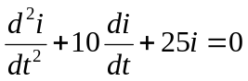

If i(0) = 10 and di(0)/dt = 0, find i(t) for t > 0.

